NORTHWOOD-FOUR CORNERS CIVIC ASSOCIATION



The Northwood-Four Corners Civic Association (NFCCA) represents 1600 households in the area bordered by U.S. 29/Colesville Road, MD 193/University Boulevard, and Northwest Branch. NFCCA appreciates the opportunity to testify as the Montgomery County Council begins consideration of the Fiscal Year (FY) 2027-2032 Capital Improvements Program (CIP).

The CIP proposes $115.16 million to finish the design and construct a barrier-separated Dedicated Median Lane for the Flash Bus Rapid Transit Phase 2 route (BRT Phase 2) on U.S. 29/Colesville Road. The cost estimate for the Median Bus Lane has now ballooned to $166 million.

As background, the US 29 Mobility and Reliability Study presented three options for Phase 2 BRT: 1) a barrier-separated Dedicated Median Lane along portions of U.S. 29, 2) a curb-running Managed Lane for public transportation (and possibly High Occupancy Vehicles (HOV), and 3) No Build. In 2022, the previous county council recommended a Dedicated Bus Lane for BRT Phase 2, but only approved funding for the 35 percent design, which is now virtually complete.

NFCCA would like to raise our strong concerns about funding further design and construction of the Dedicated Median Lane for BRT Phase 2. NFCCA believes that a Managed Lane is both more cost-effective and will serve the broader interests of all types of public transportation as well as private or commercial vehicles.

NFCCA believes the changes proposed for the Dedicated Median Lane BRT Phase 2 will decrease pedestrian safety, significantly add to inconvenience and travel time for area residents and other drivers, and close off neighborhoods’ access points at Lorain Avenue. We are also concerned that these changes will further increase cut-through traffic as drivers try to avoid the resulting congestion and traffic backups at the Four Corners intersection. The utility of a Dedicated Bus Lane is also limited, because it will only serve the Flash BRT bus, not all types of public transportation, such as Metrobus or Ride On buses, or HOV users.

Specifically, going from south to north the current BRT Phase 2 design:
- Subtracts two general travel lanes to add a two-lane, barrier-separated busway in the U.S. 29 median from the U.S. 495 beltway to Timberwood Avenue in order to accommodate moving the current Flash bus stations at Four Corners to the median at the intersection with MD 193/University Boulevard;
- Transitions to a single, barrier-separated median lane that will run from Timberwood Avenue to Stewart Lane.
- Restricts neighborhoods’ access by barrier-separating the Dedicated Median Lane, which eliminates left turns at Lorain Avenue into and out of the NFCCA and Woodmoor communities;
- Requires adding three new traffic lights: two to facilitate Woodmoor-only access at Timberwood Avenue and Crestmoor Drive and another at Hillwood Drive near Burnt Mills; and
- Involves property acquisition in Woodmoor and Burnt Mills.

The proposed changes to the Flash bus route can be viewed at https://www.montgomerycountymd.gov/dot-dte/Resources/Files/US%2029%20Flash%20BRT%20CAC%20Roll%20Plots%20September%202025.pdf

The Managed Lane option has distinct advantages—it is cheaper than a barrier-separated Dedicated Median Lane, marginally faster, and could serve HOV vehicles and all buses, not just the Flash BRT. The 2022 cost comparison showed the Managed Lane option was less expensive than various versions of the Dedicated Median Lane. Also, the 2022 study found that Flash bus drive time in a Managed Lane is marginally faster than the Dedicated Median Bus Lane alternative, because the barrier-separated Dedicated Median Lane requires additional traffic signals along Colesville Road to facilitate neighborhood access. See graph below.

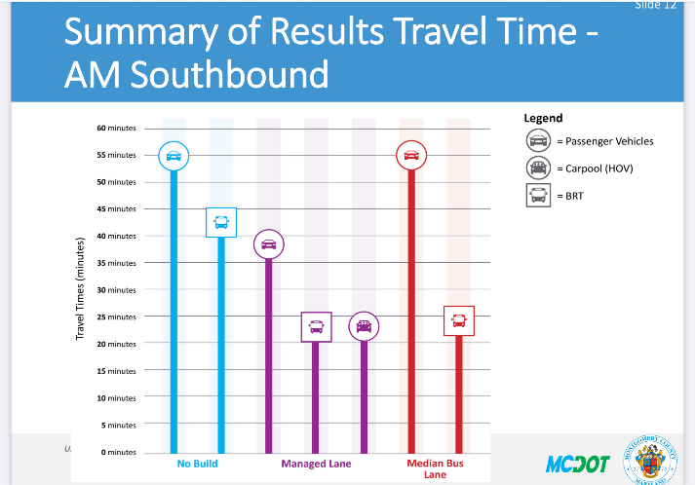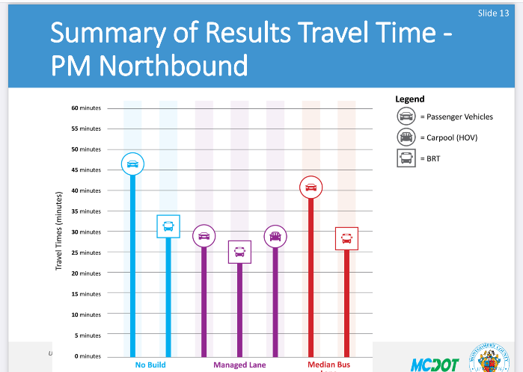

Indeed, the Council Staff Analysis and Recommendations memo, which was based on the US 29 Mobility and Reliability Study, found “Of the two build options, the Managed Lane option is clearly superior in nearly every meaningful metric.” adding “The Managed Lane option would provide the most travel time savings to all commuters, not just those who can use BRT to get to their destination.”

A Managed Lane running in the same curb lanes used by buses today will not increase vehicle backups on U.S. 29. In contrast, a Dedicated Median Lane Flash bus stop at Four Corners is designed to remove two vehicle lanes to make room for north- and south-bound BRT stations in the median, creating a traffic bottleneck right before a significant percentage of vehicles traveling on U.S. 29 exit onto I-495.

The Managed Lane option leaves the present locations of the Flash bus stations at the curb, which is safer and more comfortable from a passenger perspective than standing at a median bus station between fast-moving lanes of high-volume traffic at the Four Corners intersection. Pedestrian safety, particularly for Montgomery Blair High School students, is also a critical concern at this location.

Importantly, the Managed Lane preserves NFCCA community access at Lorain Avenue.
A barrier-separated Median Bus Lane on U.S. 29 will reduce North Four Corners and Woodmoor residents’ available entry/exit points by blocking left turns to and from Lorain Avenue. South-bound Woodmoor residents would still be able to turn left at a proposed traffic light at Timberwood Avenue, but north-bound drivers would be blocked from turning left at that traffic signal into North Four Corners.

It is unclear if the 2022 Study factored into its evaluation of the Dedicated Median Lane (both as to cost and traffic mobility) the necessity to increase both the cycle time for the Southwood Avenue traffic light and the length of the U.S. 29 turn lane. Tying up traffic near the Four Corners intersection will likely further increase cut-through traffic into the NFCCA neighborhood so, at a minimum, a traffic study analysis should be performed to evaluate neighborhood impact from reduced access points and cut-through traffic.

Proponents of the Dedicated Median Lane argue that a barrier-separated lane will eliminate non-compliance by scofflaws, but an interesting finding of the University Boulevard Corridor Plan was that there is only 1 percent non-compliance for the managed bus lane on MD 193/University Boulevard.

Before moving forward with the BRT Phase 2, NFCCA urges the Council to reconsider the current plan and, at a minimum, to explore the differential in both cost and travel time efficiency between the Managed Lane and a Dedicated Median Lane.

By investing $115 million in BRT Phase 2, as proposed, the county will do nothing to relieve drive time for cars and commercial vehicles, including carpoolers and other transit riders (Metro and RideOn) as well as commuters who need to drive. NFCCA is concerned that the Dedicated Median Bus Lane is not the optimal alternative because it is costlier, does not improve drive time conditions on U.S. 29, and more specifically, would limit neighborhood access for Four Corners residents, increase neighborhood traffic backups, further intensify cut-through traffic, reduce pedestrian safety, and add three additional traffic signals along this half-mile stretch of U.S. 29. A decision to fund the BRT Phase 2 Dedicated Median Lane ignores the safety of and access to nearby communities and sacrifices the quality of life for Four Corners residents who must live with the inconvenience and cut through traffic in Four Corners.

NFCCA believes the Managed Lane alternative is less costly, less disruptive, more efficient, more user-friendly and delivers its benefits more widely. In closing, NFCCA is asking Councilmembers to consider CIP funding for the study, design, and construction of the Managed Lane option for implementation of BRT Phase 2 on U.S. 29.

Submitted by:
Sharon Canavan
NFCCA President
10213 Edgewood Avenue
2 March 2026

US 29 Mobility and Reliability Study, 2020 at https://www.montgomerycountymd.gov/dot-dte/Resources/Files/US29Study/Documents/US%2029%20%20Mobility%20Study%20Report%20July2020.pdf and the US 29 Mobility and Reliability Study, Technical Addendum 2022 at https://www.montgomerycountymd.gov/dot-dte/Resources/Files/US29Study/Documents/US%2029%20%20Mobility%20Study%20Report%20Addendum%20Nov2022.pdf
See 2022 cost estimates for Managed Lane vs. Median Lane in the U.S. 29 Mobility and Reliability Study: Report Addendum at page 10, at https://www.montgomerycountymd.gov/dot-dte/Resources/Files/US29Study/Documents/US%2029%20%20Mobility%20Study%20Report%20Addendum%20Nov2022.pdf
US 29 Mobility and Reliability Study – Project Findings, U.S. 29 Corridor Advisory Committee Update, October 6, 2022 at slides 12, 13 at https://www.montgomerycountymd.gov/dot-dte/Resources/Files/US29Study/US29-Mobility-Study-Cont_Proj-Findings_10_13_2022-Public-Meeting.pdf
Glenn Orlin, Memo to Transportation and Environment (T&E) Committee, “Council Staff Analysis and Recommendations” November 28, 2022 at page 5, https://www.montgomerycountymd.gov/council/Resources/Files/agenda/cm/2022/20221128/20221128_TE1.pdf
In a peak hour, approximately 45 vehicles traveling north-bound on U.S. 29 turn left onto Lorain Avenue. See U.S. 29 Mobility and Reliability Study: Report Addendum at page 15, at https://www.montgomerycountymd.gov/dot-dte/Resources/Files/US29Study/Documents/US%2029%20%20Mobility%20Study%20Report%20Addendum%20Nov2022.pdf

